Targeted BR&E Program
OHIO STATE UNIVERSITY EXTENSION
Module 4 - Survey

Agri-business Activities

- Which of the following best describes your farm/agriculture business?

Agriculture, forestry, fishing & hunting production

- Oilseed & grain farming
- Vegetable & melon farming
- Fruit & tree nut farming
- Greenhouse, nursery & floriculture production
- Other crop farming
- Cattle ranching & farming
- Hog & pig farming
- Poultry and egg production
- Sheep & goat farming
- Aquaculture
- Other animal production
- Support activity for crop production

Manufacturing

- Animal manufacturing
- Grain & oilseed milling
- Sugar & confectionary product manufacturing
- Fruit & vegetable preserving & specialty food manufacturing
- Dairy product manufacturing
- Animal slaughtering and processing
- Bakery & tortilla manufacturing
- Other food manufacturing
- Beverage manufacturing
- Tobacco manufacturing
- Pesticide, fertilizer & other chemical manufacturing

Wholesale trade

- Agriculture, construction, mining, machinery manufacturing
- Farm product raw material merchant wholesaler
- Miscellaneous nondurable good merchant wholesalers

- In terms of ownership, how do you best describe your business? CHECK ALL THAT APPLY

- Publicly held (stock)
- Private/ Sole Proprietor
- Employee-owned
- Family-owned
- Nonprofit
- Headquarters of multi-unit firm
- Branch office of multi-unit firm
- Corporation
- Others

- How long has this business been operating at your current location? SELECT ONE ANSWER

- Less than 1 year
- Between 1-5 years
- Between 5-10 years
- Between 10-20 years
- More than 20 years

Employment

- Including owner-operators, how many employees work at this location? SELECT ONE ANSWER

- 1-4 employees
- 5-9
- 10-14
- 15-19
- 20-29
- 30-49
- 50-99
- 100-299
- Over 300 employees

- What percentage of your employees live:

_____ % Within your city/community
_____ % Outside your city/community but within county
_____ % Outside county

Past Employment

- During the past 3 years, has the number of employees in this business ….? SELECT ONE ANSWER

- Increased
- Decreased
- Stayed the same
- What factors are responsible for this change? CHECK ALL THAT APPLY

- New products/services
- Renovation or expansion
- Corporate decision or policies
- Increase/decrease in market competition
- Increase/decrease in market share
- Management effectiveness
- Increase/decrease in sales
- Others

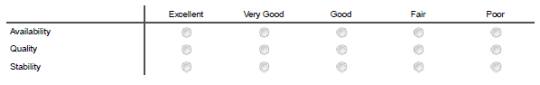
- How do you rate the availability, quality and stability of the workforce in this area for your business?

- Are you able to recruit sufficient qualified employees for your business? SELECT ONE ANSWER

- Yes
- No

- On a scale of 1-5, (1 being less skilled to 5 highly skilled) how would you rate the skill profile of your company's workforce? SELECT ONE ANSWER

- Very low skilled
- Less skilled
- Uncertain
- Skilled
- Highly skilled

Future Employment

- In the next 5 years, do you think the number of employees in your business will increase, decrease or remain the same?

- Increased
- Decreased
- Stayed the same

- If there will be an increase in the number of employees, what factors will be responsible for this increase? CHECK ALL THAT APPLY

- Contracts/outsourcing
- Increase or decrease in market share
- Entering new market
- New products or services to be introduced
- Increase or decrease in sales
- Renovating or expanding
- More or less subcontracting
- Corporate decision or policies
- Management effectiveness
- Increasing or decreasing market competition
- Technological changes
- Other (please specify)

Financial Status

- Please estimate the percentage of your gross sales to:

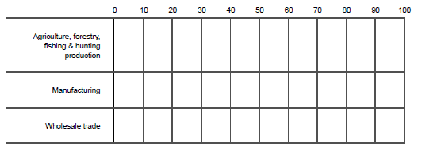

- Please estimate the gross sales ($) of your business. Check the appropriate sales level for each year.
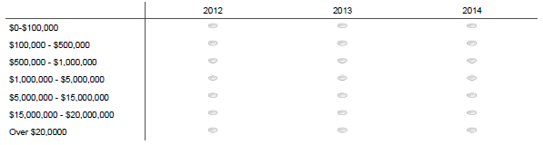

- Do you have a current business plan?

- Yes
- No
- Don't Know

- How far in advance do you plan your financial performance? SELECT ONE ANSWER

- Not at all
- Monthly
- Quarterly
- Yearly
- 2 years
- Other (please specify)

- During the past 3 years how did your agri-business operation’s financial situation change? SELECT ONE ANSWER

- Deteriorated
- Stayed the same
- Improved

- Which of the following factors affecting the ag‐industries above will cause your income to decrease over the next three years? CHECK ALL THAT APPLY

- Changing market conditions
- Overcrowded facilities
- Land limitation for expansion
- Workforce issues
- Rigid code enforcement
- High taxes
- Lease expiration
- Retirement
- None of the above
- Other:

- Do you expect to sell or transfer some or all of your farm assets within... SELECT ONE ANSWER

- 1 to 5 years
- 6-10 years
- 11-15 years
- 15 + years
- Don’t expect to sell/transfer

- Will that sale/transfer be to... SELECT ONE ANSWER

- To family members
- To unrelated party

Sources of Inputs

- Where do you purchase the majority of your agri-business supplies? CHECK ALL THAT APPLY FOR EACH SUPPLY. Please specify the county if it different from your own county.

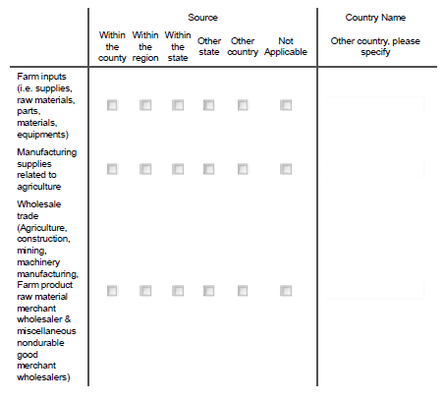

Marketing

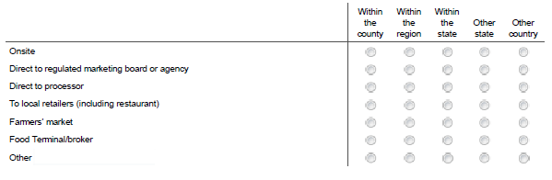
- Where do you currently market your product (primary and/or processed) and where are they located geographically?

- Do you currently import/export products? If yes, please specify the corresponding country(s).

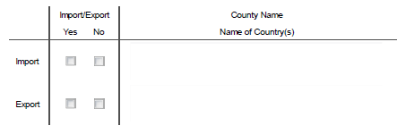

Marketing Technique

- What types of marketing technique have you found successful? CHECK ALL THAT APPLY

- Distributors
- Direct mail
- Directory listings
- Sponsorship of activities and events
- General publications
- Trade show attendance
- Fliers/brochures
- Social media & company website
- Radio advertisements
- Television advertisements
- Newspaper advertisements
- Business cards
- Word-of-mouth
- Others (please specify)
- How often do you use the following SOCIAL MEDIA in marketing your agri-business and contacting your customers? Do you think your customers found you using the following social media?

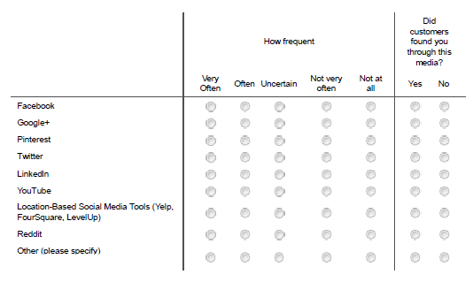

Marketing Plans (Local Market)

- Have you considered pursuing any new niche market opportunities? SELECT ONE ANSWER

- Yes
- No

- Do you currently feel that local marketing of producers is important? SELECT ONE ANSWER

- Yes
- No

- Would you be interested in supplying local markets (retailers/institutional buyers) if the distribution and management systems were in place? SELECT ONE ANSWER

- Yes
- No

- How could the local market potential of your agricultural products be enhanced? CHECK ALL THAT APPLY

- Increase Buy Local marketing
- Local Food product labelling
- Access to a local abattoir
- Direct marketing to local consumers
- Additional local processing or value-added
- Access to local distribution channels/networks
- Improved transportation
- New or different role for marketing boards
- Other (please specify)
- Not applicable

- Do you have the capacity to increase production to supply local markets if additional buyers were identified? SELECT ONE ANSWER

- Yes
- No

- What products or services would you like to purchase locally that are now being purchased outside of the area? CHECK ALL THAT APPLY

- Abattoir
- Specialty seeds
- Biogas technology
- Boiler service
- Cheese cultures
- Flour (consistent supply)
- Farm supplies
- Fertilizer
- Greenhouse fruits/vegetables
- Local food products (groceries)
- Utilities
- Organic beans/lentils
- Plastic for bunkers
- Raw materials
- Wool
- Others (please specify)

- What could be done in the community to improve the marketing of your agricultural products?

- Is lack of access to markets affecting your agri-business? If yes, please describe.

Affiliation with Formal/Informal Business Organizations

- Are you active in any formal or informal group of other business leaders where you can confidentially share your experiences and learn from your peers?

- Yes
- No

34.1 If YES, are these local groups?

  - Yes
  - No

34.2 If NO, do you see any importance of being connected with other groups
of agri-business leaders?

- Yes
- No

- Are you interested in working cooperatively with other businesses in your community to pursue any of the following in the future? CHECK ALL THAT APPLY
Business Growth & People behind Growth

- Does your CEO spend more or less time focusing on growth strategies than they were five years ago? Please explain your answer.
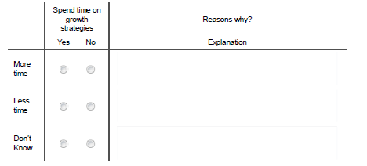

- If you could make strategic hires that can help you focus more on opportunities for growth, what would these additional people do?

- What special skills would they need to qualify to do the job?

Growth Strategies

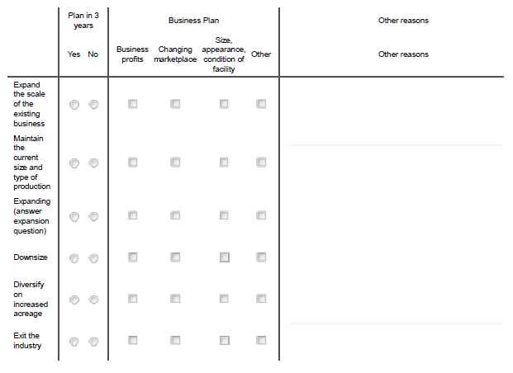
- Which would best describe your plans for your business over the next 3 years? SELECT ONE ANSWER

- How interested are you in growing your business?

- In what areas of your operation is the growth coming from? Check all that apply

- Opening another location
- Licensing your product
- Offering your business as a franchise or business opportunity
- Forming an alliance

Diversifying

- Sell complementary products or services
- Import or export yours or other products
- Introduce new products or services to existing customers
- Others

- Win a government contract (have the federal government as a customer)
- Selling more of their same products or services to new customers
- Target other markets
- Customer retention
- Expand globally
- Develop or enhance website
- Use social media
- Others

Expansion

- If you are planning to expand the scale of your business, will your expansion lead to an increase in the following? SELECT ALL THAT APPLY

- Demand for skills training
- Process improvements
- Exporting
- Importing
- Investment in equipment/technology
- Services for customers
- Product lines
- Floor space
- Workforce
- Others

- Which new businesses, services or products would you like to see added to your community? SELECT ALL THAT APPLY

- Abattoir
- Food processing and post-harvest value-added activity
- Restaurant
- Farm supply store (e.g. Farm Co-op)
- Others (please specify)

Community Climate for Agri-Business

- Please rate the local agri-business climate. SELECT ONE ANSWER

- What are the biggest opportunities for local businesses in your community? Check all that apply.

- Local food movement
- Agricultural hub
- Agricultural service/supply
- Quality farmland
- Value-added agriculture
- Culinary and Agri-tourism
- Support for agriculture
- Improve local marketing
- Others

- What are the biggest challenges facing local businesses in this community? Check all that apply.

- Local food movement/Regulation
- Competition from big box stores/cities
- Workforce issues
- Limited local demand
- Transportation
- Others

- What are your specific recommendations to improve the local business climate? Check all that apply.

- Local food movement/Reduce red tape/Lessen regulations
- Promote local food and products
- Improve local marketing/customer service
- Public education about food and farming
- Legislative support for agriculture
- Government support and assistance for local business
- Attract/develop/support value-added agriculture
- Encourage diversification
- Environmental protection and awareness
- Others

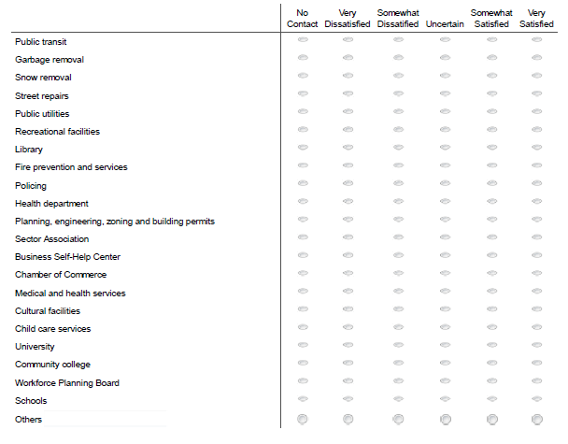
- What is your level of satisfaction with each of the following services provided by community organizations and local government?
- List your community’s 3 advantages as a place to do business. Select only 3 reasons

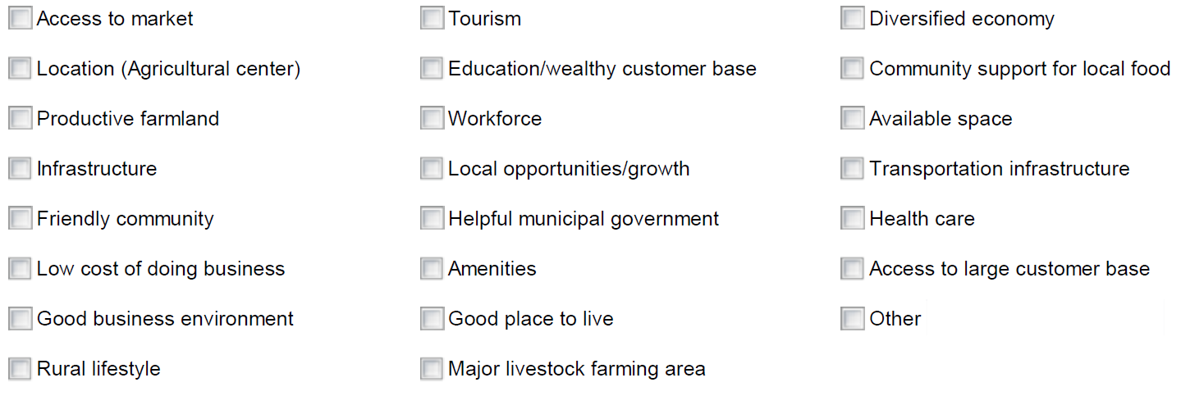

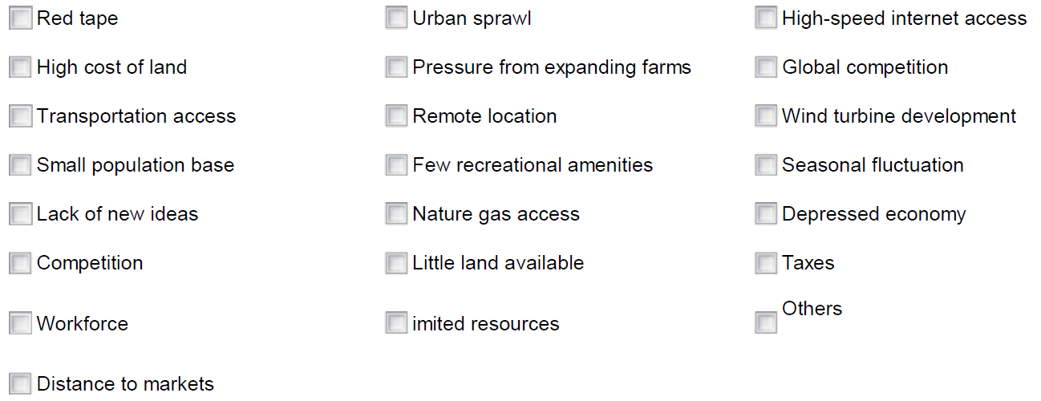
- List the community’s 3 disadvantages as a place to do business. Select only 3 reasons

Barriers to Growth

- What are the barriers to your agri-business operation? Check all that apply

Regulatory approvals

- Food inspections/approvals
- Building permits and regulations
- Zoning bylaws
- Organic certification
- Red tape
- Other (please specify)

- Access to capital
- Uncertain markets
- Labor availability
- Land costs
- Access to land
- Securing necessary farm services
- Other

- Please indicate which of the issues will be considered barriers to the expansion of existing businesses and to the development of new businesses in the community. Check all that apply

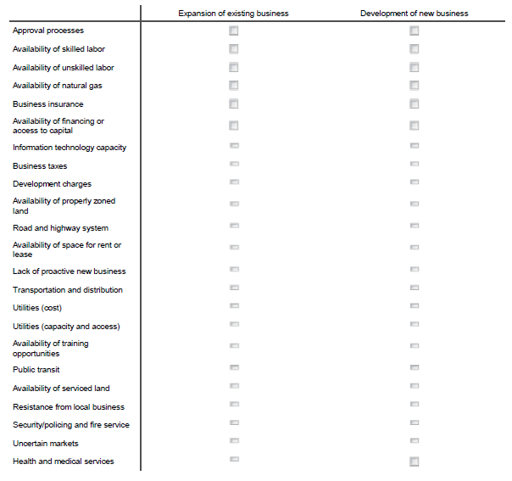

- Which of the following factors related to your use of information technology/internet are barriers to your business? CHECK ALL THAT APPLY

- No barrier
- Speed
- Access
- Cost
- Knowledge
- Staff training
- Market development
- Online sales
- Time to learn and stay current
- Privacy
- Trouble shooting
- Other (please specify)

- Is access to financial planning expertise a barrier to your business’ growth? SELECT ONE ANSWER

- Yes
- No

- Is access to or knowledge of financing or lending sources a barrier to your business’ growth? SELECT ONE ANSWER

- Yes
- No

Information Assistance

- What information/assistance do you need to include processing as part of your farm business? (CHECK ALL THAT APPLY)

- Health Unit approvals
- Market research
- Marketing plan
- Business plan
- Local processing facilities
- Feasibility study
- Securing land use & planning approvals
- Securing financing
- Other (please specify)

Local Government Assistance

- In what ways could local government assist the agriculture sector in your area?

- Streaming of local regulatory and permitting processes
- Infrastructure maintenance and improvement
- Review of taxes and fees
- Database of available local farm labor
- Other (please specify)

- In what ways could local/regional economic development organizations assist in increasing local food supply, demand and distribution? CHECK ALL THAT APPLY

- Promote Buy Local campaigns
- Connect food producers and processors with local consumers through marketing and distribution
- Provide local food distribution hub
- Develop networking and communication channels between food producers and local
- Other (please specify)

- What assistance, if any, could the community, local government or economic development organizations give to support your business? CHECK ALL THAT APPLY

- E-marketing
- Website development
- Productivity improvement workshops
- Identification of opportunities for shared use of resources
- Workforce planning, employee training, etc.
- Attraction of related supply & services businesses
- Joint advertising and marketing
- Export development programs and services
- Business networking sessions
- Trade shows
- Access to capital seminars
- Marketing seminars
- Other (please specify)

